Count the total number of W-electron candidates and the total number of W-muon candidates.

Calculate electron-to-muon ratio:
No. e | No. μ | e/μ

Contribute your numbers of e and μ to group totals.

Your Z mass plot:
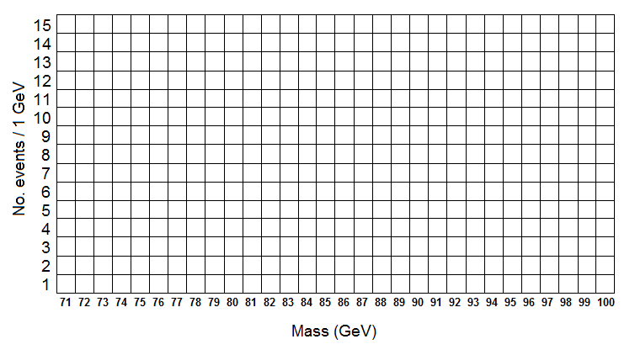
Place an X in the appropriate mass bin for each event. Start from the bottom so that the vertical axis represents the number of events in that bin.

Contribute the total number of events in each bin to the group mass plot.

